Caribbean Advanced Proficiency Examination

Information Technology Unit 1



**Centre:** Mona High

**Centre Number:** 100152

**Name of Candidates:** Syee Dassado, Chevannese Ellis, Joel Laird, Kirklan Reynolds, Shamarly Edwards

**Candidate Numbers:** 1001520294, 1001520359, 1001520618, 1001528020, 1001520340

**Teacher:** Mrs. Lettman

**Territory:** Jamaica

**Year:** 2022-2023

***Table of Contents***

Acknowledgment 3

Introduction4

Problem Definition 5

GANTT Chart 6

Analysis of the Problem 8

Identification and Justification of Tools Used 10

Assessment and Implications on Solutions 12

Solution 14

Human User Interface 15

Bibliography 19

Appendix 20

# Acknowledgment

The completion of this project wouldn't have been possible without the help of God who gave the group members the strength and courage to carry out this assignment. Also, the researcher's classmates played a major role in providing the necessary research data for this project. Lastly, the group's amazing teacher Ms. Lettman, who helped guide us along the way.

# 

# 

# Introduction

This report is geared towards students in sixth form at Mona High School who are in need of a website that can be used in the preparation of their external examinations. In this research, you will find out what issue students face with the educational sources available at Mona High School. Also in this project, you will find the possible solutions to solve the problems that the school has and how effective the solutions are.

# Problem Definition

At Mona High School, sixth form students are given various researches to complete for individual subject areas. Due to the covid-19 Mona High School has been operating with a duality of face-to-face and online. There is currently one librarian who operates the library during school hours of 8 o'clock am to 2:30 pm. As such students are expected to utilize these hours. Although the library operated in a suitable time frame, the educational resources offered by the school are outdated and not ample for the students' research and studies. This leads to the issue of misconceptions on areas being taught to the students. The institution needs a digital solution to help organize the students’ subjects along with the necessary tools for users. The Mona High Upper Six Association would like to create a website for the students in the lower and upper six to assist them with studying.

# GANTT Chart

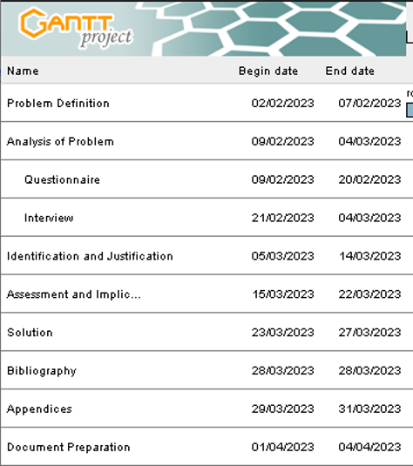

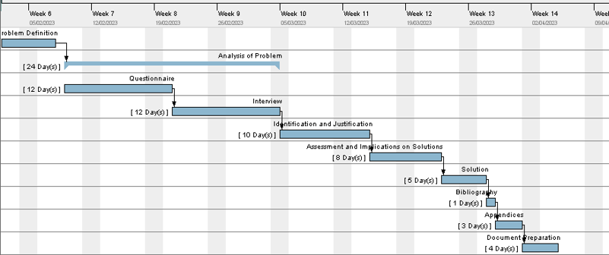

# 

# Analysis of the Problem

As a method of data collection, the following were used: a questionnaire and an interview.

Firstly, the questionnaire was prepared with seven closed-ended questions to twenty-six participants in the sixth form on February 9, 2023. The use of the questionnaire allowed not only timely data from a large sample size but also great ease in analyzing the responses in regards to the availability of educational resources. Based on the five choices in question three that were given in the questionnaire, it was found that 38.5% of the students found online resources offered by Mona High School moderately helpful whereas interestingly enough 38.5% of them found it slightly unhelpful. Based on question two of the questionnaire, it was observed that 65.4% of students found online learning to be average whereas the second-highest choice was 15.4% that had poor as their experience with online learning. In response to question six of the questionnaire, 100% of the respondents do not have access to every e-book for all their subjects for free. From the questionnaire, it is clear that Mona High School needs to improve the online resources they offer and also improve their online learning experiences.

Secondly, an interview was prepared with five open ended questions to five participants in sixth form on March 21, 2023. The interview was the other means of data collection due to its supremacy of immediate in-depth responses from students in the school. This was also used to clarify key questions and responses presented in the questionnaire for the researcher to better assess the required information to determine if it is suitable to address the issue of the research with an electronic solution. According to the responses of the interview, 60% of students highlight that it has been an issue with accessing e-books for their CAPE subjects and believe there is not ample period to cover the syllabus. The remaining students were satisfied with their experiences in obtaining e-books, yet they recommend that the school itself should provide more online resources for the preparation for the external exams. Both data collection proves that this aspect of the institution needs to ameliorate and prepare its candidates to fulfill their upcoming assessment.

# Identification and Justification of Tools Used

The choice of a website was chosen as it provides various methods to connect with our clients. Following the use of software development software was used to construct and implement this idea. A hierarchical model was the most suitable choice for an organizational system as it provides a clear and concise view of the structure; it also provides a user-friendly aspect which encourages use.

**Website** - The software platform that was used was Wix due to its endless possibilities in web page design. Wix has a user-friendly UI with easy Web Hosting. Using this software was easy as it provides an endless amount of customization that uses a drag-and-snap method which provides no prior coding experience. The use of links and attachments can also be used for easy navigation of resources.

**Hierarchical layout (chart)** - Having a structured layout of individual web pages creates a logical relationship that users, especially the creator can understand. This allows the creator to organize the pages in harmony on the website while improving the readability of each page. Additionally, they show which pages are the most important to provide guidance on which ones should be focused and assessed more often.

**Customized Template** - A customized template consists of layouts that are created and adjusted in a way you want for all of your pages. This will be a very useful and essential tool when creating the website. A major reason why this tool was chosen is for its incredible reusability. It is very reusable because you are not only able to re-edit and change the layout whenever and however you want but you are also able to re-use the same layout for a different and entirely new page.

# Assessment and Implications on Solutions

To ensure the website fulfills essential criteria and is running effectively, certain factors need to be assessed.

**Navigational (Workflow) Bugs Issues -** This is a frequent issue encountered when constructing and maintaining a website's existence. Bugs are commonly known especially when using a website. To be specific, navigational bugs on a website are generally frustrating and costly. They often result in executing things that they are not intended to do. If an individual selects a particular subject like "Management of Business" as a menu on the website and this leads to another page displaying another subject like "Accounting". This is indeed a workflow bug. The solution to this issue is to assign a few group members to test each page thoroughly by pinpointing and rectifying these bugs.

**Security Issues** - A major issue with the use of websites is security. The sixth form students of the websites are given an option to create their account with the use of a suitable username, password, and email account. Due to this, there is the likelihood that these personal data, especially the email address, will be stolen and misused. If this malicious act becomes unaware to the creator of the e-learning center then it is known that the site is vulnerable to hackers such as spammers who snatch email addresses by unsolicited emails.  Due to this, there may be a need to execute encryption or an installation of antivirus to constitute a higher level of security.

**Cost** - There were not any issues with creating the website on the software platform of Wix. The software platform was free to use as Wix offers a free plan that includes the variability of the website's domain based on the registered email address. However, when officially publishing the website, the software platform will charge a fee whenever changing the website's domain. That is the drawback of using Wix in terms of its cost.

# Solution

The sixth form students often have problems with the lack of resources for their various subjects. As a result, an ideal solution for this issue would be to create a website to assist students' studies. This will enable the students to have easy access to a wide range of valuable information with precise accuracy and efficiency, including information on every different subject available on the website. The website contains information such as overview of the subject, syllabus, e-books, along with different online teachers that are available and past papers based on the specified units of the subject. This will increase the likelihood of a student excelling in their academics as he/she has access to educational resources with ease online.

Link to website: <https://monahighsixformtut.wixsite.com/six-form-tutor>

# Human User Interface

Link to website: <https://monahighsixformtut.wixsite.com/six-form-tutor>

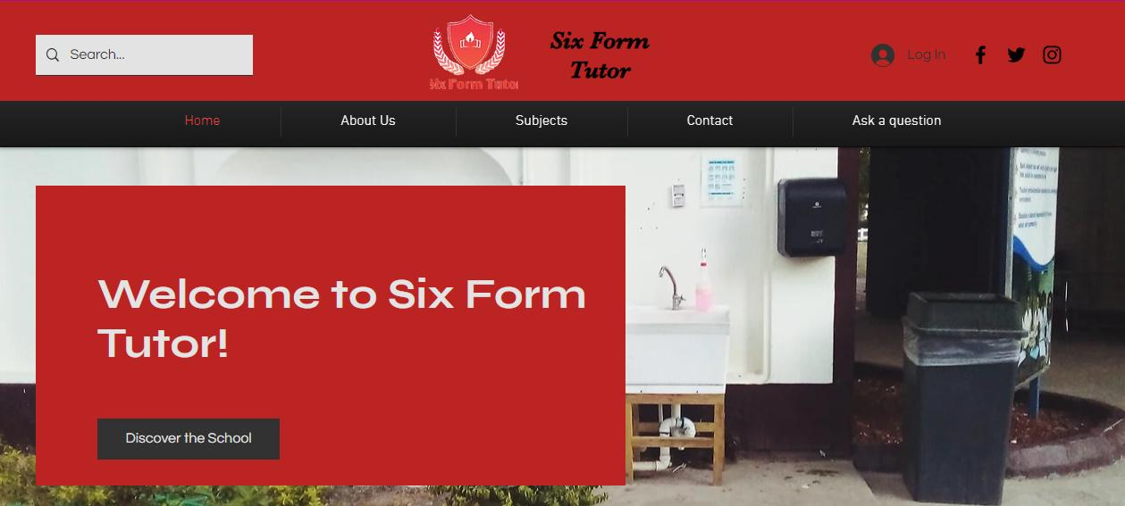

This is the screenshot of the Home/Welcome Page of the website.

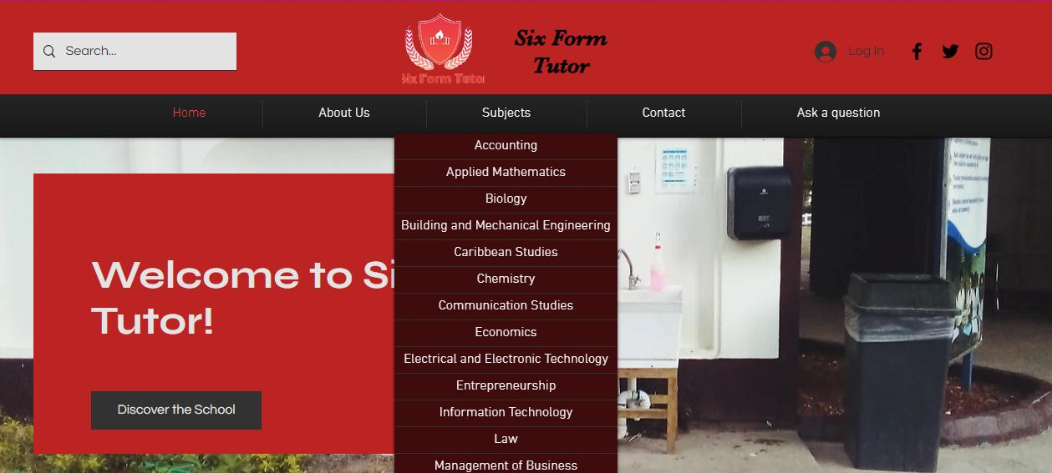

The user can select any of the various subjects from the drop down menu from “Subjects”.

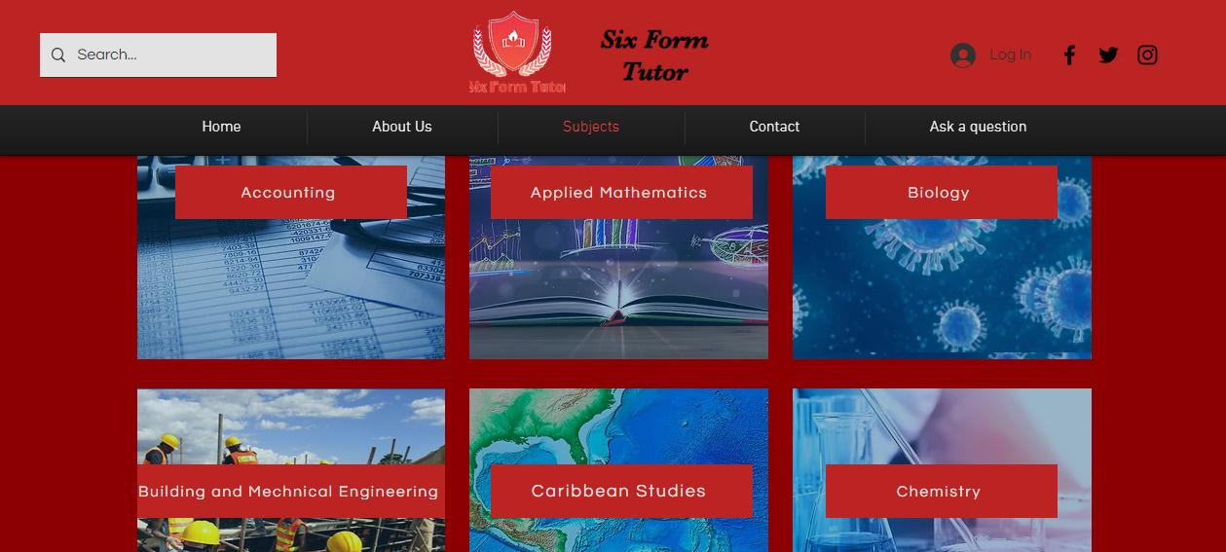

This is a screenshot of when the user clicks on “Subjects”. This helps the user to select from all of the subjects that are currently available.

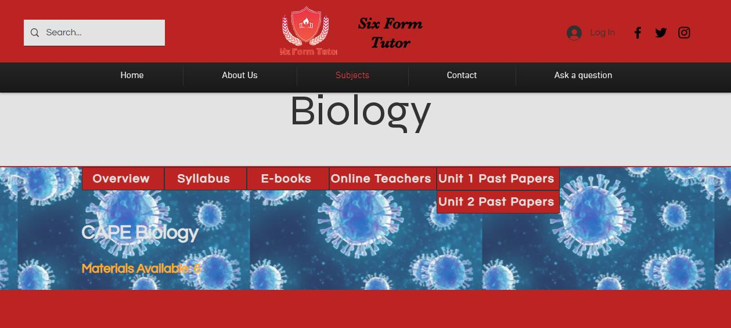

This is a screenshot of the potential options the user will see when they choose a specific subject to learn from.

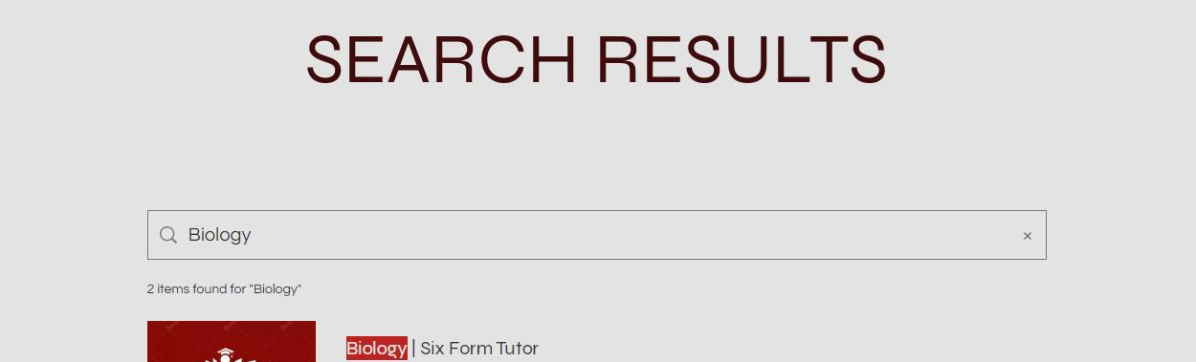

This is a screenshot of the search results when trying to find a specific page

# Bibliography

AGRIFFITHS11. (2015). Retrieved February 4, 2022, from UNIT 2 IA Assistance: https://maggottyhighcapeit.wordpress.com/unit-2-ia-assistance/

Sixth Form Tutor. (2022). Home | Six Form Tutor. Retrieved March 21, 2022, from

<https://monahighsixformtut.wixsite.com/six-form-tutor>

Unadkat, J. (2021). *6 Common Types of Software Bugs Every Tester Should Know*. Retrieved March 21, 2022, from BroswerStack: https://www.browserstack.com/guide/types-of-software-bugs

# Appendix

**Questionnaire**

**Instruction:** In each question in the questionnaire, please tick the option that you most likely agree most with. There is no right or wrong answer. Your answers will be recorded anonymously and you will not be identified.

1. What is your gender?

☐Male

☐Female

2. How do you feel about learning online?

☐Excellent

☐Good

☐Average

☐Below Average

☐Poor

3. How helpful has Mona High School been in offering you resources to learn online?

☐Extremely helpful

☐Very helpful

☐Moderately helpful

☐Slightly unhelpful

☐Not very helpful

4.  Has it been difficult for you to find e-books for your various subjects?

☐Not at all difficult

☐Slightly difficult

☐Moderately difficult

☐Very difficult

☐Extremely difficult

5. How available are Mona High teachers to contact outside of school hours when trying to learn at home?

☐Very Easily Available

☐Easily Available

☐Sometimes Available

☐Slightly Unavailable

☐Extremely Unavailable

6. Rate on a scale of 1-5 your experience with having access to e-books for all your subjects for free. (Consider 5 extremely well and 1 being terrible)

☐5

☐4

☐3

☐2

☐1

7. Rate on a scale of 1-5 your experience with finding online teachers who teach your specific subjects. (Consider 5 extremely well and 1 being terrible)

☐5

☐4

☐3

☐2

☐1

**Responses from Questionnaire**

**Figure 1:** Pie Chart representing responses to the question, “What is your gender?”

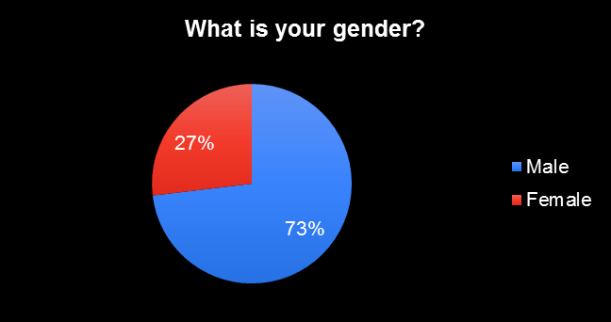

**Figure 2:** Pie Chart representing responses to the question, “How do you feel about learning online?”

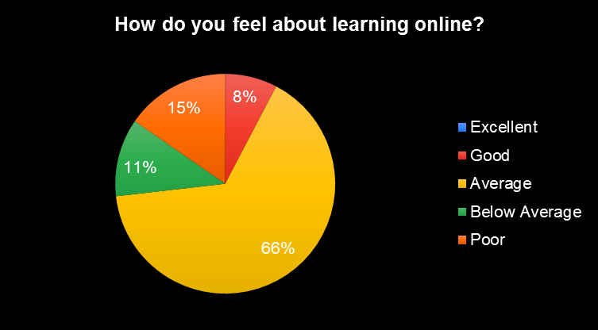

**Figure 3:** Pie Chart representing responses to the question, “How helpful has Mona High School been in offering you resources to learn online?”

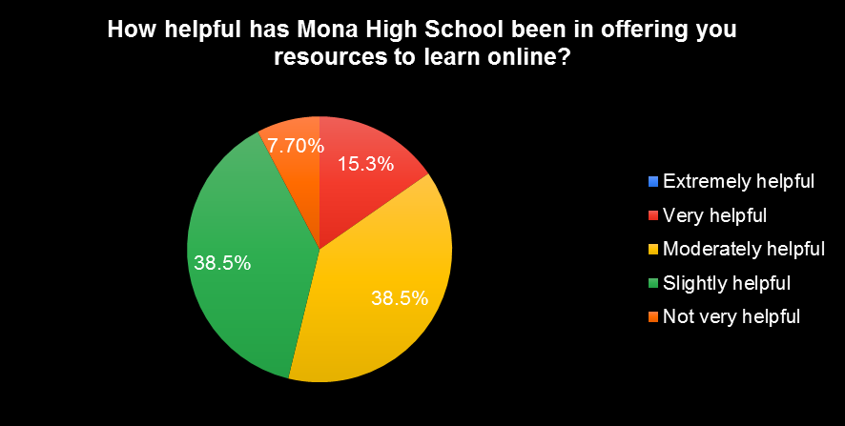

**Figure 4:** Pie Chart representing responses to the question, “Has it been difficult for you to find e-books for your various subjects?”

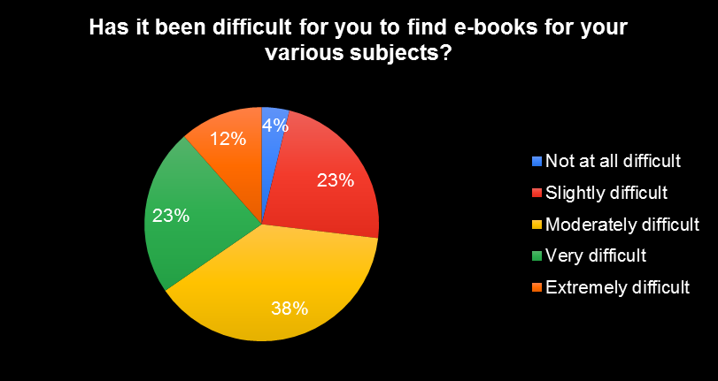

**Figure 5**: Pie chart representing responses to the question, “How available are Mona High teachers to contact outside of school hours when trying to learn at home?”

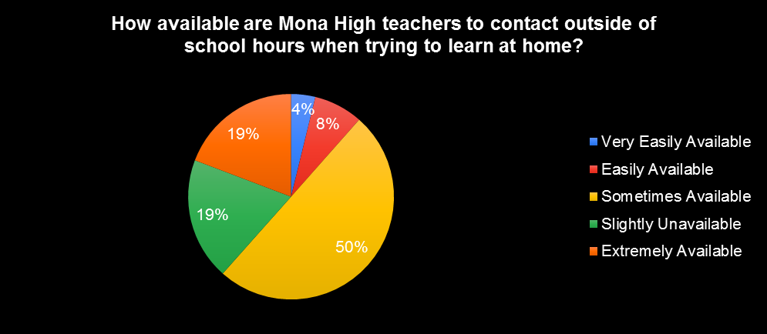

**Figure 6**: Pie Chart representing responses to the question, “Rate on a scale of 1-5 your experience with having access to e-books for all your subjects for free.”

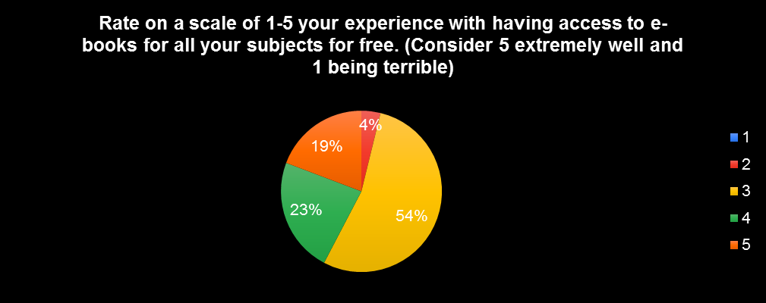

**Figure 7:** Pie Chart representing the responses to the question, “Rate on a scale of 1-5 your experience with finding online teachers who teach your specific subjects.”

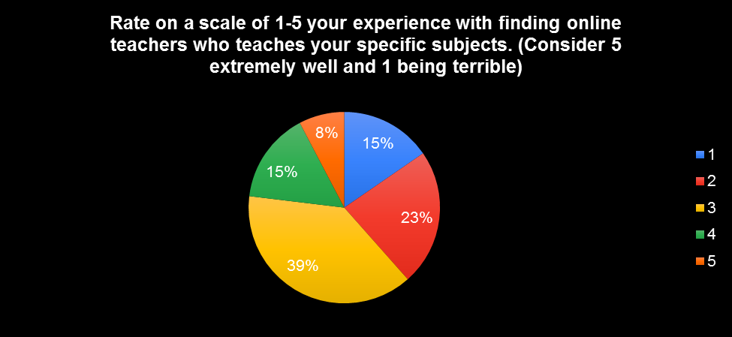

**Interview Questions**

**Instruction:** In each question in the interview, please write and respond with your honest opinion. There is no right or wrong answer. Your answers will be recorded anonymously and you will not be identified.

1. What is your experience with trying to acquire e-books for all your CAPE subjects? Explain your answer.

2. What is your experience with finding online teachers that teach your CAPE subjects? Explain your answer.

3. Do you feel that Mona High School could provide additional online resources to support students preparing for their upcoming CAPE Examinations? Give your honest reason.

4. Based on the pace at which the syllabus is being covered by the teachers, do you feel that there will be adequate time to properly study the entirety of the subject’s content?

4b. If not, explain your reason why.

**Table 1**: Represents the responses from the interview questions.

|  |  |  |  |  |  |
| --- | --- | --- | --- | --- | --- |
| **Questions** | **Respondent#1** | **Respondent#2** | **Respondent#3** | **Respondent#4** | **Respondent #5** |
| 1. What is your experience with trying to acquire e-books for all your CAPE subjects? Explain your answer. | It is difficult. Because    most e-books available are just previews and we have to pay for them and some subjects it is hard to even find e-books for them. | It hasn't really been an issue; I have acquired ¾ e-books for my CAPE subjects. | It is pretty easy to acquire e-books because I have a website that provides these books for free. | It has been very difficult to obtain e-books because of the limited information on where to find them. | It's been a major issue in obtaining e-books, especially the comprehensive free ones for my respective subjects in sixth form. Most of them are typically unavailable or require payment to access them. |
| 2. What is your experience with finding online teachers that teach your CAPE subjects? Explain your answer. | It has been hard because there are a limited number of teachers focusing on teaching online to CAPE students as we are said to be pre-university students. | I haven't found any teachers teaching CAPE subjects online or anything really advertising these sessions. | The experience with finding online teachers has been good, I haven't found any difficulties. | Very difficult- The reason being not many people teach the subject that I do and some don't speak English properly. | It has been difficult since there are only a few teachers who teach CAPE subjects since it's generally more advanced than CXC. The further in education, the rarer the resources are available for that level in ascension. |
| 3. Do you feel that Mona High School could provide additional online resources to support students preparing for their upcoming CAPE Examinations? Give your honest reason. | Yes because even though we are CAPE students we still need resources that may seem hard to find online. | Yes. Mona High School providing additional online resources to students would be extremely beneficial to us, as they would help us to prepare for my exams. | Yes, I believe Mona High School could provide more by allowing students to use the school WI-FI for free. | Yes, this will help greatly with studying and preparing with CAPE in these times. | For sure, the more aid they can provide in our preparations, the more likely we would succeed in the examinations. |
| 4.Based on the pace at which the syllabus is being covered by the teachers, do you feel that there will be adequate time to properly study the entirety of the subject’s content? | No, I don't believe so. | Yes, I believe that there will be adequate time to properly study the different subjects. | Yes, I believe there is enough time to complete the syllabus. | I do not believe we have. | No |
| 4B.If not, explain your reason why. | By the time the syllabus is completed it would leave at least a 2 week period for us to study everything for each subject. That is indeed inadequate time to study thoroughly. | (The respondent said yes on question #4.) | (The respondent said yes on question #4.) | Due to the pandemics' late registration and the length of the syllabus, we would need more time to be prepared. | Well since many subjects just started Module 2 and the external exams start in May, I am distressed that we will not be able to cover the syllabus; however, I'm trying to be as optimistic as possible in aspiring we can do so though. |

**Layout Diagram**

